Question 1

Given:

- Standard normal distribution curve.

Find:

a. Area between 𝑧 = 0 and 𝑧 = 1.3.

b. Area to the right of 𝑧 = 1.87.

c. Area to the left of 𝑧 = −0.7.

d. Area between 𝑧 = −1.47 and 𝑧 = 2.39.

Diagram:

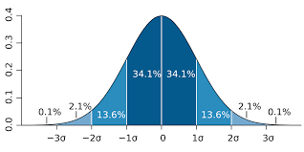

Theory:

- The standard normal distribution curve is a probability density function with a mean (𝜇) of 0 and a standard deviation (𝜎) of 1.

Assumptions:

- Assuming we are working with the standard normal distribution.

Solution:

1. For area between 𝑧 = 0 and 𝑧 = 1.3, the area is about 0.4032.
2. For the area to the right of 𝑧 = 1.87, the area is about 0.0307.
3. For the area to the left of 𝑧 = −0.7, the area is about 0.2420.
4. For the area between 𝑧 = −1.47 and 𝑧 = 2.39, find the area to the left of 𝑧 = 2.39 and subtract the area to the left of 𝑧 = −1.47. Using a standard normal distribution table, the area to the left of 𝑧 = 2.39 is about 0.9933, and the area to the left of 𝑧 = −1.47 is about 0.0708. Area between these two values is approximately 0.9933 - 0.0708 = 0.9208.

Question 2

Given:

- Mean (μ) = 80

- Standard Deviation (σ) = 6.0

Find:

- Probability of a student having a quiz grade of 95 or greater.

Diagram:

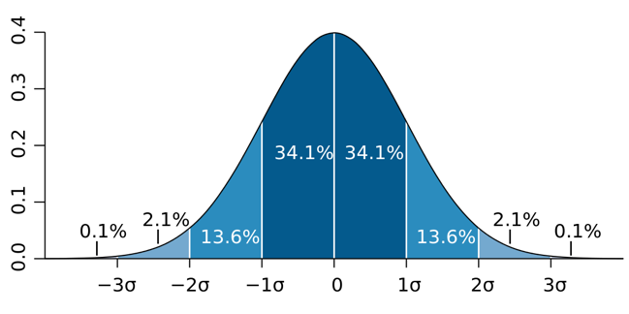

Theory:

To find probability, use the standard normal distribution and the z-score formula:

- Z is the z-score.

- X is the value we want to find the probability for.

- μ is the mean.

- σ is the standard deviation.

Find the z-score for 95 and then use the z-score to find the probability using the z-table

Assumptions:

Quiz grades follow a normal distribution.

Solution:

Calculate the z-score for a quiz grade of 95:

$$Z= \frac{95-80}{6.0}=2.5$$

from scipy.stats import norm

# Find the cumulative probability for Z = 2.5 (probability of grade ≥ 95)

cum_prob_grade_95_or_greater = 1 - norm.cdf(2.5)

# Print the result

print(cum_prob_grade_95_or_greater)

When I ran this code, it will output the probability:

Probability of a student having a quiz grade of 95 or greater: 0.0062097 or .62%

Question 3

Given:

- Mean (μ) of Dr. Pepper dispensed = 63.0 oz

- Standard Deviation (σ) of Dr. Pepper dispensed = 1.75 oz

- Cup capacity = 64.0 oz

Find:

- Probability that a randomly selected cup will be overfilled.

Diagram:



Theory:

To find the probability, use the standard normal distribution and the z-score formula:

- Z is the z-score.

- X is the value we want to find the probability for (cup being overfilled at 64.0 oz).

- μ is the mean.

- σ is the standard deviation.

Assumptions:

The amount of Dr. Pepper dispensed follows a normal distribution.

Solution:

Let's calculate the z-score for a cup being filled to 64.0 oz:

$$Z= \frac{64-63}{1.75}=0.5714$$

from scipy.stats import norm

# Find the cumulative probability for Z ≈ 0.5714 (probability of overfilling)

cum_prob_overfill = 1 - norm.cdf(0.5714)

# Print the result

print(cum_prob_overfill)

Probability of a randomly selected cup being overfilled: 28.57%

Question 4:

Given:

- Mean lifetime (μ) of LED light bulbs = 4,600 hours

- Standard deviation (σ) of lifetime = 250 hours

- Desired proportion of bulbs burning out before claimed lifetime = 4.0%

Find:

- The lifetime the company should promote for these bulbs.

Diagram:



Theory:

To find the promoted lifetime, find the value of lifetime, X, such that only 4.0% of bulbs burn out before this claimed lifetime.

- Z is the z-score corresponding to the desired proportion.

- X is the claimed lifetime we want to find.

- μ is the mean lifetime.

- σ is the standard deviation.

Assumptions:

Assume that the lifetime of the LED light bulbs follows a normal distribution.

Solution:

(0.04) = -1.7507. Use the z-score formula to find the claimed lifetime (X):

$$-1.7507= \frac{X-4,600}{250}$$

The company should promote a lifetime of about 4,162.325 hours for these LED light bulbs to ensure that only 4.0% of them burn out before the claimed lifetime.

Question 5

Given:

- Mean lifetime μ of electric scooters = 15 years

- Standard deviation σ of lifetime = 1.75 years

- Percentage of scooters to be replaced p = 5.0%

Find:

- The length of the guarantee (in years) that the manufacturer should offer.

Diagram:



Theory:

Find a lifetime, X, such that the manufacturer is willing to replace 5.0% of the scooters that fail before this time. This involves finding value (z) from the standard normal distribution corresponding to the percentage 5.0%, and then using it to calculate the lifetime.

The z-score formula is:

- Z is the z-score.

- X is the desired lifetime.

- μ is the mean lifetime.

- σ is the standard deviation.

Assumptions:

Assume the lifetimes of electric scooters follow a normal distribution.

Solution:

$$-1.645= \frac{X-15}{1.75}$$

The manufacturer should offer a guarantee of approximately 12.11 years to be willing to replace 5.0% of the scooters that fail before that time.